
The Wealth of health

Martins Oak Newsletter
January 2026

Our Mission SAtatement
To improve the health, well being and lives of those we care for.
Educate and prevent disease in well patients.
Care for and review patients with chronic diseases.

It’s not the strength of the body that counts but the strength of the spirit – JR Tolkien
Welcome to our new look Patient Newsletter. It will be produced every month and will be available electronically via our website/Facebook or there will be paper copies available in the reception waiting room.
The purpose of the newsletter is to inform patients of Practice news, updates and the wider primary care messages. This edition contains managing winter ailments, get to know our paramedic – Crawford and prescriptions explained
Your feedback on our newsletter is welcomed and we would be delighted to hear of any ideas and content you would like to see in future editions.
You can send these to admin.martinsoak@nhs.net

Timely issues
Managing winter ailments
To stay healthy in the winter, get vaccinated for flu and covid, stay warm by dressing in several thin layers which traps the heat rather than one thick layer. Keep your home heated ideally around 18°c and keep windows shut at night. Eat a balanced diet with plenty of fruit and vegetables, staying hydrated with fluids and hot drinks. Eat a hot meal at least once a day to keep your body warm.
Admin.martinsoak@nhs.net 
01424 772060

Stay active with daily movement to keep your circulation healthy and if possible, go for a brisk walk to get some daylight, being cautious on slippery surfaces.
You should also prioritise mental health wellbeing, wash hands to prevent germ spread and seek advice from pharmacists or NHS 111 for minor illnesses.

Dry January
Dry January is an annual challenge, spearheaded by Alcohol Change UK, that encourages people to give up alcohol for the entire month of January. Participants often experience benefits such as better sleep, more energy, improved mental health, weight loss, lower blood pressure and a reduced risk of certain diseases. The challenge serves as a reset for the mind and body.

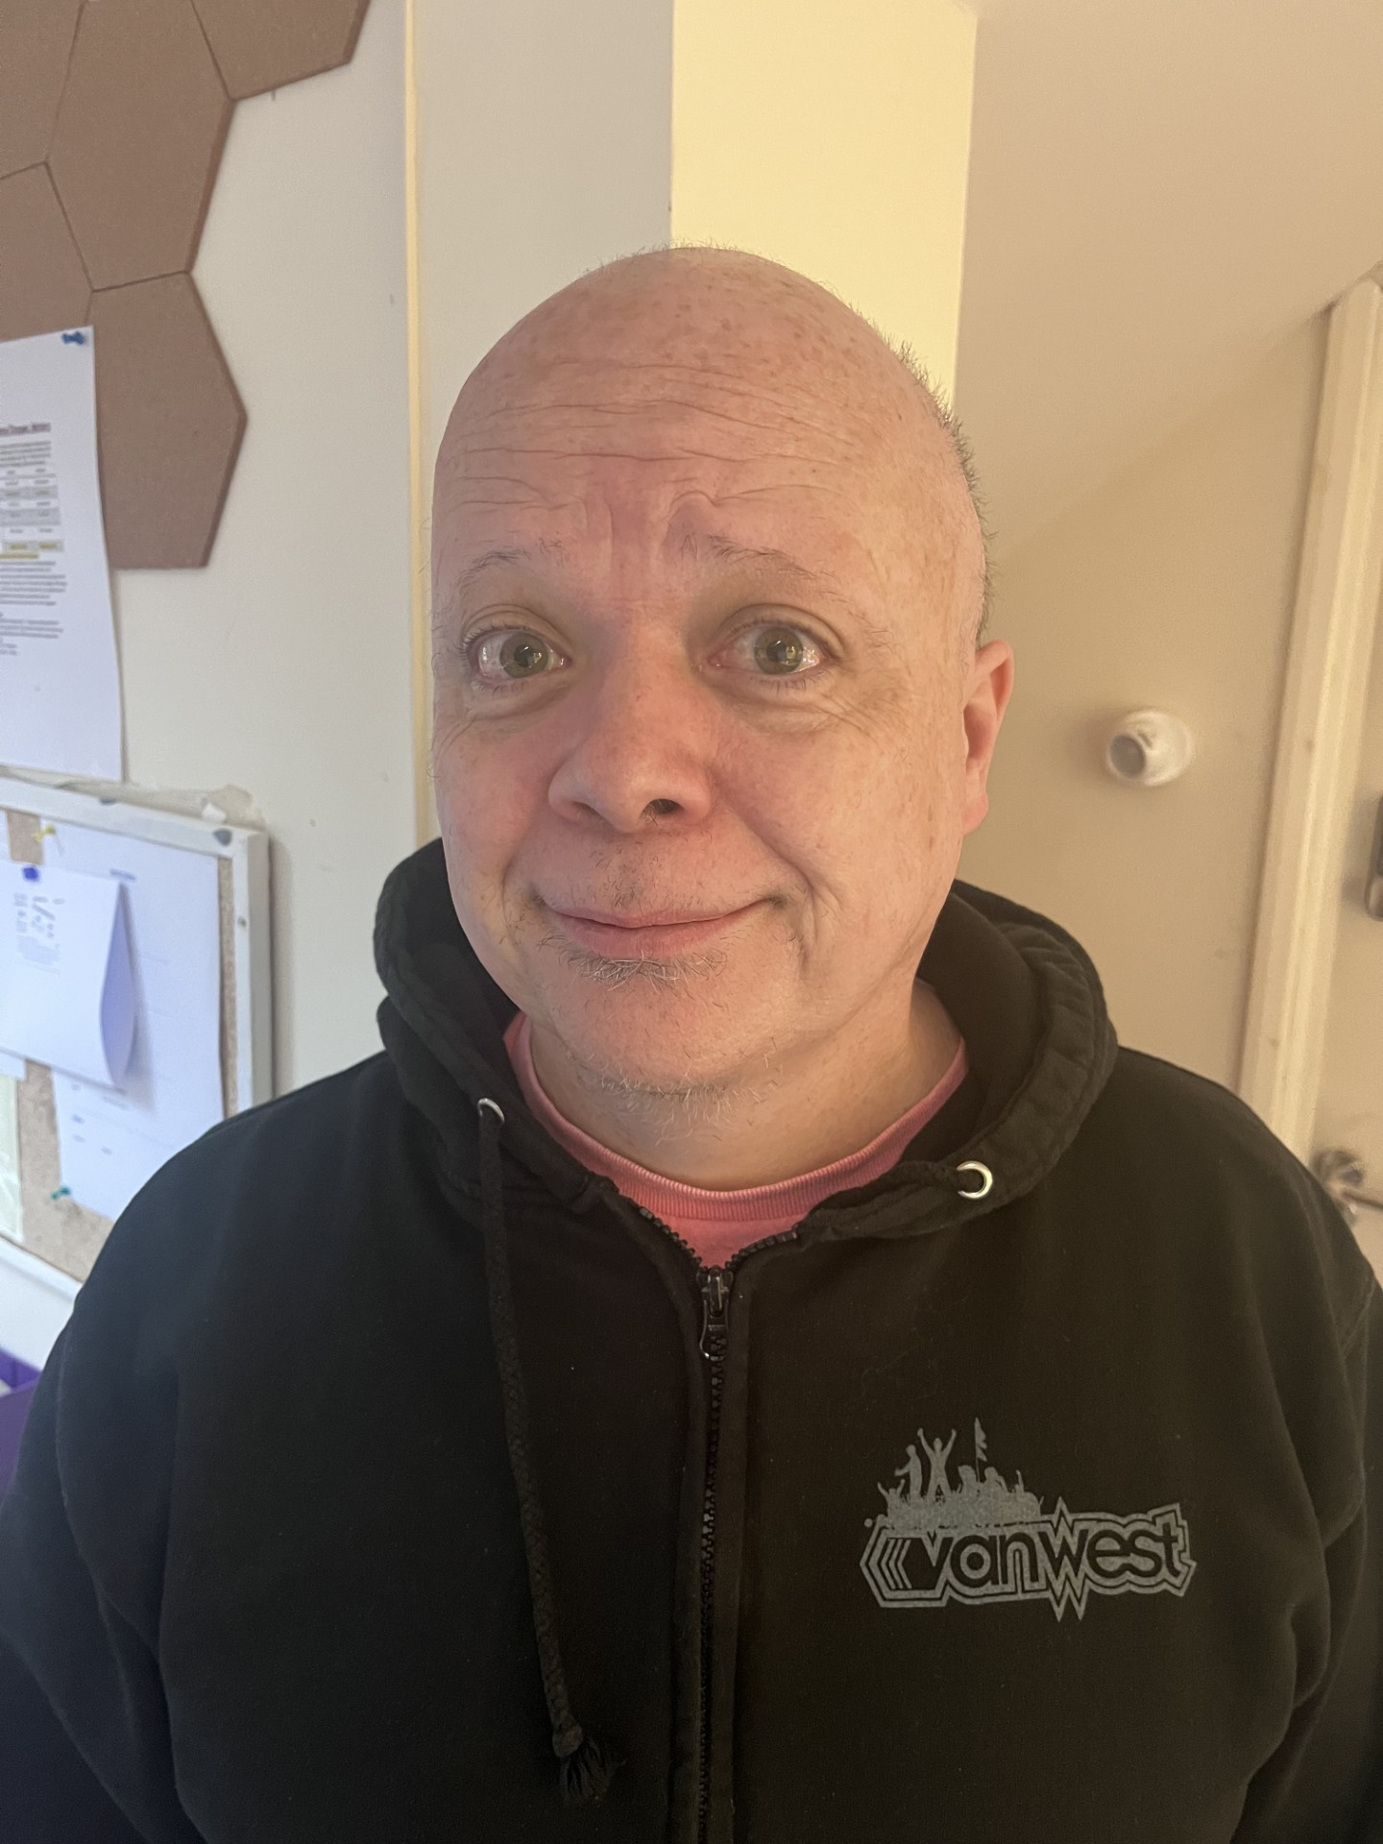
get to know our CliniCians
Surgery Paramedic – Crawford Paton
I have been at Martins Oak Surgery for 3 years, initially part time but now I am full time doing clinics and home visits. I am an experienced paramedic with 25 years frontline emergency care for the ambulance service, however latterly trained in community paramedic management of acute illness. My clinics are for acute illnesses such as chest infections, ear infections, MSK and skin problems. I may send you for an x-ray or I may also see you for an ECG, phlebotomy or chronic illness review.
I am married with 4 children, enjoy camping, walking the dog Rocket and I have a collection of VW vehicles to keep me busy when I am not at work.

Prescriptions – different types explained
Acute – these are issued for short term or one-off medication such as a course of antibiotics for an infection. Medication may stay on acute so the GP can keep an eye on it.
Repeat – these are used for long term conditions where the patient take medications regularly. Patients can order these medications without seeing a GP every time, often through the NHS app.
Patients Comments
Thank you for the outstanding help and care shown to us both, it is so much appreciated. Above all the kindness.
I boast to friends what a lovely surgery I get to go to. I give you all 10 out of 10

Also a big thank you for all the Christmas gifts you kindly gave the practice, we share them out equally as it’s a team effort.. They are much appreciated.

