**Martins Oak Surgery**

**Newsletter**

**www.martinsoak.co.uk**

Volume 2 Issue 1 Late Winter/Spring 2024

**Editor’s Comments**

***(Sam Bridgewater – Co Practice Manager)***

Firstly, apologies for the lapse in our newsletters. The last newsletter you will have seen was for summer 2023 and I apologise for the absence of updates during the autumn and winter seasons.

The warmer months are hopefully on their way but in the meantime there are a few things you can do to help keep you and your family safe and well over the colder months.

**Keep Warm & Well**

  
Stay warm and well in East Sussex with the "Keep Warm and Well" initiative. This program provides a complimentary Warm Home Check service for residents, offering practical advice and COVID-secure support.

The service not only gives advice but also assists in securing financial support to keep your home warm. If your heating system needs attention, they can help with repairs, draft excluders, or provide a temporary heater. Larger projects like home insulation and heating system upgrades may be supported based on funding availability.

For free advice and support, visit warmsussex.org.uk, contact 0800 464 7307, or text WARM to 80011.

**NHS App**

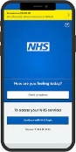

Access a variety of NHS services easily and securely through the NHS App. Simply download it from the Google Play or App Store onto your smartphone or tablet. Alternatively, access the same services via a web browser by logging in through the NHS website.

Unlock full access by verifying your identity and gain the ability to:

Order repeat prescriptions and nominate a preferred pharmacy for collection

Book and manage appointments

View your GP health record, including information on allergies and medicines. If granted access to your detailed medical record, you can also see test results. Register your organ donation decision

Control how the NHS uses

your data

Retrieve your NHS number and discover what it is

Utilize NHS 111 online for immediate advice or medical

assistance near you.

**Pharmacy First**



NHS England has introduced "Pharmacy First" to alleviate pressure on General Practice. Eligible patients are encouraged to use community pharmacies for prompt care of minor illnesses, aligning with the NHS philosophy of "Right patient, Right place, Right time." Skip contacting the surgery for assessment and treatment of common conditions; your pharmacy can provide suitable medication, whether prescription strength or over-the-counter. Access the Pharmacy First service through online booking or walk-ins, and your healthcare provider may direct you there for optimal advice and treatment.

**Bexhill Diagnostic Centre**



Patients who need blood tests

can now book an appointment at Bexhill

Community Diagnostic Centre. Appointments are available six days a week, including same day appointments. Free parking is available. For more info visit: <https://swiftqueue.co.uk>

**Measles**

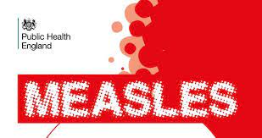

Measles can cause serious complications, such as pneumonia, meningitis, blindness and seizures. After a 30-fold increase in measles

cases in Europe in 2023, increased rates of measles in the UK suggest that we may see a significant increase in the number of cases here too.

This is partly due to the reduced levels of vaccination against measles.  
If you or your child hasn’t received two doses of the MMR vaccination, please contact the surgery to see if you can be vaccinated.

**Free NHS Wifi**

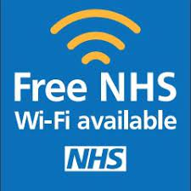

We now offer free NHS Wifi within the practice. Search for NHS Wifi in ‘wifi networks’ on your device, register, and next time it will connect you automatically.

**Travel Clinic**



Traveling abroad? Ensure you're vaccinated by seeking advice 6 to 8 weeks before your departure. Pick up a

travel questionnaire from

reception or our website.

After submitting it, we'll contact you about necessary vaccinations and associated costs. Schedule an appointment with our practice nurse at your convenience.

**Rural Rother PCN**



Working with other surgeries in the area we are able to provide a number of services within our Primary Care Network, including: First Contact Physiotherapists

Social Prescriber

Cancer Care Co-ordinator

Clinical Pharmacists

For more information visit the Rural Rother website – ruralrotherpcn.nhs.uk

**Please be kind to our staff**

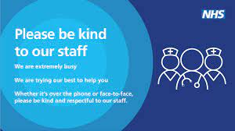

Sadly, we feel the need to remind patients to please treat

our staff with courtesy and respect.

Our staff do not deserve to be faced with aggressive behaviour or to be sworn at simply for doing their job. Our staff are doing an amazing job and are doing their best with the resources available to them.

Treating our staff in a disrespectful manner does

nothing to support recruitment or retention at a time when morale in General Practice is already low.

The challenges faced by healthcare professionals, especially since the COVID-19 pandemic, are significant, and it's crucial for patients to

understand the limitations and pressures on the healthcare system. General Practice is not an emergency service.

Many matters can be dealt with over the phone or a face-

to-face appointment will be

allocated, if required.

Examples of URGENT conditions, include a new lump, new infection, severe pain. Please book a routine appointment for ongoing issues, follow-up results, etc.

**Patient Participation Group**

Martin’s Oak Surgery is enhancing its Patient Participation Group (PPG) and seeks patient representatives for valuable feedback on our services. As a representative, you'll contribute to discussions, decision-making, and service development. Our current PPG of 4 members meets every 2-3 months, aiming to expand to 7-8 people. A "virtual" PPG via email is also being created for broader participation.

To join either group, contact us at ppgmartinsoak@gmail.com with your name, address, and telephone number or pick up an application form at the surgery. Your input is crucial in shaping the future of our services.

**Closed**

Description: MCj04415740000[1]

We are closed:

Staff Training – Tues, 5 Mar 2024 (Afternoon only)

Good Friday – Fri, 29 Mar 2024

Easter Monday – Mon, 1 Apr 2024

Early May – Mon, 6 May 2024

Spring Bank Holiday – Mon, 27 May 2024

During this time if you need medical advice please use NHS 111.